**Concurrency Model**

Even if the SetTimeout has a timer of 5000ms than also the the cb() is executed once the complete code is executed which is after 10000ms and upto this time the timer has already expired and the cb() executes once the complete code is executed and the callstack is empty as the eventloop monitors the callstack and once it is empty it passes the cb() to call stack from the callback queue and then executes cb().

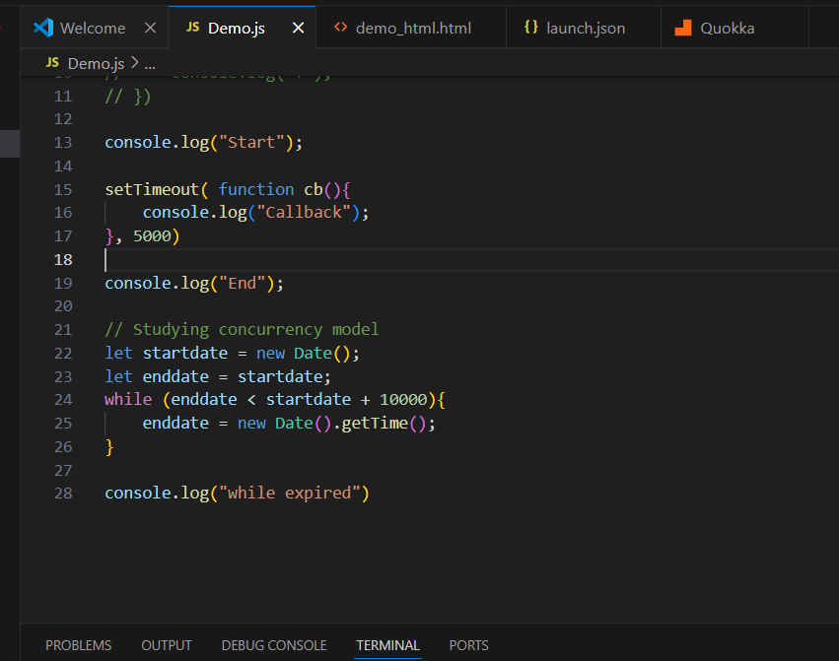

o/p:

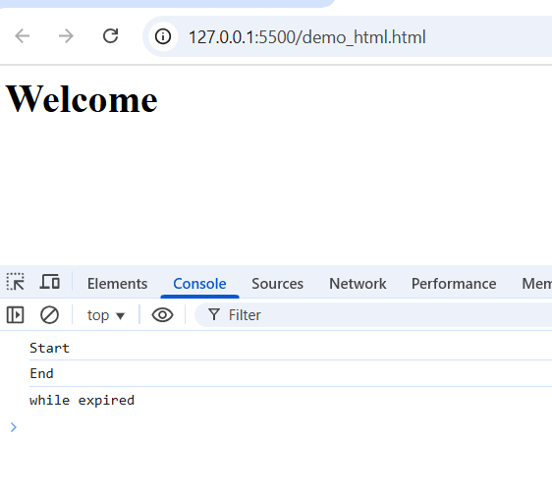

**Higher order function (functional programming )**

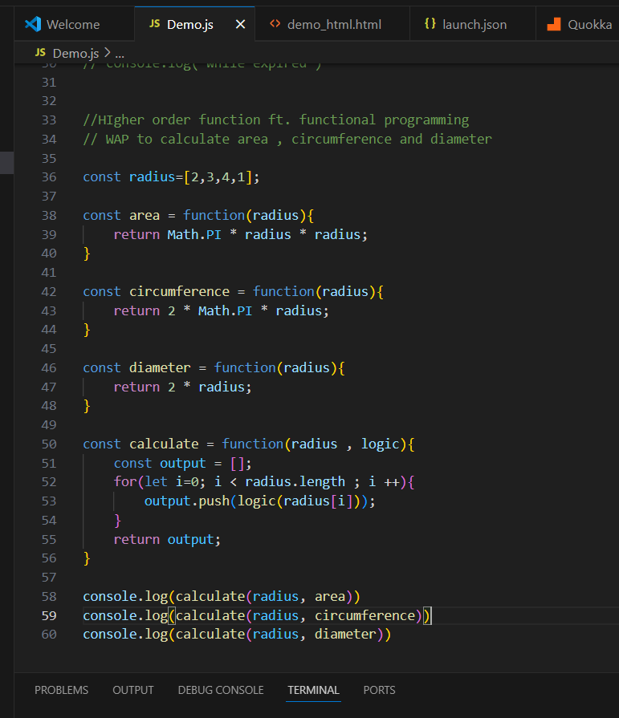

**O/p:**

